|  |
| --- |
|  |
| CONJUNTION ANALYSIS & VISUALISATION OF ORBITAL SPACE OBJECTS |
| Undergraduate Thesis Research Proposal |
|  |
| Joel Stuart |
| Bachelor of Engineering (Software)  School of Information Technology and Electrical Engineering |

|  |
| --- |
| The project aims to contribute to greater Space Situational Awareness using a 3D software environment as a means to facilitate investigation of non-Gaussian error volumes and collision analysis of orbital elements. |

1.0 Introduction

Since the beginnings of space travel in 1957, the space around our earth has been becoming increasingly congested. As of 2010 there are over 770 active satellites in either Low Earth Orbits (LEOs), Geostationary Earth Orbits (GEOs) or between (Mid Earth Orbits – MEOs) and over 16,000 pieces of catalogued debris larger than 10cm that are being tracked [1]. In the uncatalogued domain there and millions more objects that have yet to be identified [1]. The current overcrowding problem is projected to escalate as additional space missions are launched and as pre-existing debris collides and shatters, further compounding the problem [2].

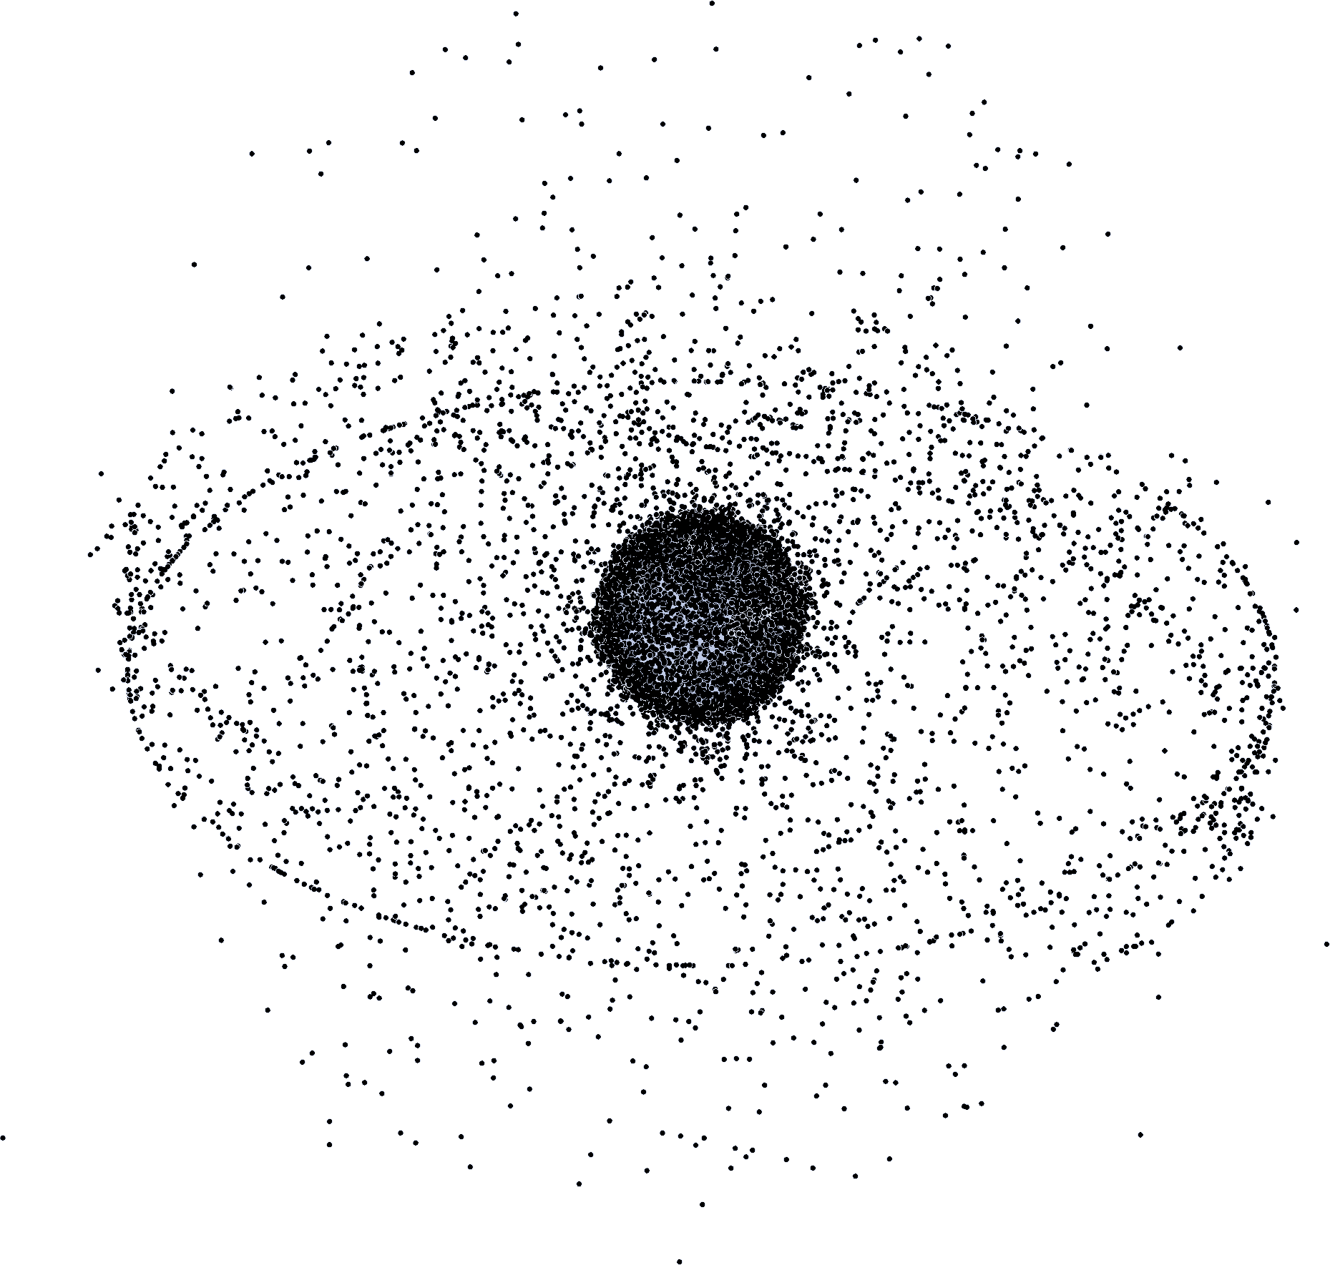

Figure 1.1 NASA graphic of space debris around earth [3]

In Australia, Optus is responsible for a large portion of the telecommunications infrastructure. According to the Australian Space Environment Research Centre (SERC) their fleet of geostationary satellites has a commercial worth of over $8 billion [4]. This entire fleet must be monitored to mitigate risks of collision with debris.

An impact with an orbital object can cause catastrophic damage to an operational satellite, such as shown by the 2009 collision between the active Iridium 33 satellite and the non-operational Kosmos 2251, producing many thousands of pieces of debris larger than 1cm [5]. This debris will continue its orbit for decades to come. As space debris cannot currently be plausibly removed from orbit [5], Space Situational Awareness (SSA) and Space Surveillance and Tracking (SST) are essential to protecting and maintaining satellite systems.

**1.1 Space Surveillance and Tracking (SST)**

To attempt to address the massive problem of managing and tracking the countless orbital objects, catalogues of debris fragments, active and inactive satellites are maintained by international agencies. These catalogues can be used to analyse the probability of conjunctions between catalogue elements and thus the risk of collisions between high value assets and debris. These risk calculations assist with threat identification and preparation and deployment of avoidance measures.

With the sheer numbers of orbit debris objects in the tracking catalogue, it is necessary to filter this catalogue into subsets which can more feasibly be analysed for conjunctions. These subsets can be obtained using geometrical or temporal filters [6]. These subsets can be analysed with root and extrema finding algorithms to isolate time intervals when a pair of elements pass within a specified proximity threshold relative of each other [6]. With this greatly reduced problem space, conjunction analysis can be feasibly carried out on the close proximity pairs [6, 7, 9, 10].

**1.2 Conjunction analysis**

Traditional conjunction analysis uses the assumption that orbital elements will behave according to a roughly Gaussian error model [7, 12, 13]. This assumption supresses the true non-Gaussian nature of satellite position uncertainties [8, 9, 10, 11]. A proposed solution for this shortcoming is to treat the non-Gaussian error model as a sum of Gaussian elements, modelling variables such as state noise or measurement noise, which can be assumed to be Gaussian [9, 10]. This is known as the Gaussian Sum or mixed-Gaussian method.

Particle representations can also model the non-Gaussian nature of the object. Using particle generation techniques, uncertainty can be represented for any orbital object with known elements [11]. As illustrated in Fig. 1.2, the Gaussian mean can be significantly off centre relative to the true probability density function (pdf).

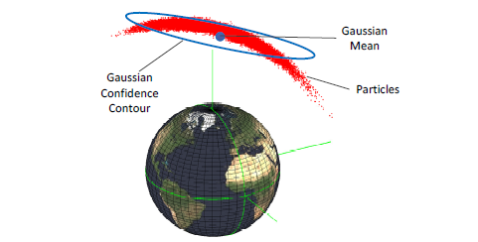

Figure 1.2 Gaussian and particle representations of an orbital object’s uncertainty (image from [11])

**1.3 Space Situational Awareness Visualisations**

Using data from publicly available SST catalogues and a propagation modeller called the Standard General Perturbations Satellite Orbit Model 4 (SGP4) [14, 15] catalogue elements can be propagated forward in time. The standard data format for SGP4 objects is the two-line element set (TLE) which encodes various orbital elements for an Earth-orbiting object for a given moment in time [16].

AGI, a leading commercial space analytical graphics company is responsible for many software solutions for commercial SSA [17], but these packages are very costly and do not include non-Gaussian collision analysis.

2.0 Proposal

The aim of this project is to build a computer program to automatically visualise and analyse orbital tracking data in an interactive 3D rendered environment. This project will explore using non-Gaussian uncertainty volumes of orbital objects via 3D particle representations to convey collision risks in an intuitive and innovative way.

The purpose of this project is to contribute to greater Space Situational Awareness using a 3D software environment as a means to facilitate investigation of non-Gaussian error volumes and collision analysis of orbital elements.

The rationale for this project is to explore in greater depth non-Gaussian conjunction analysis & visualisation methods and to provide access to an interactive 3D environment for academic collision analysis.

2.1 Methodology

This project will use Two Line Element (TLE) datasets from publically available SST catalogues using sources such as SpaceTrack [18] to achieve snapshots of real satellites and orbital debris. It will use the high-level MATLAB computing language and calculation environment to investigate the collision analysis domain in both simulated scenarios and on SST catalogues for real world applications. The reduced scope of generated scenarios will support the verification and testing of functionality to speed up the development process.

Particle representations that model uncertainty be generated by adding noise to each orbital element of each object in the problem space, using co-efficient parameters specified in [11].

To achieve smooth interactive visualisations without compromising accuracy of simulation or suffering from processing bottlenecks, the project will support both real time and pre-rendered options, GPU utilisation for parallelisation (natively supported by MATLAB)[11] and filtering algorithms to narrow the problem space for conjunction analysis purposes [6, 9, 11, 13]. Rendered simulations will able to be saved for later use and will allow iterative analysis and filtering to be performed.

To facilitate interaction with the 3D environment, keyboard, mouse and GUI controls will give the user options to explore and analyse the problem space.

2.2 Risks and Resources

This project will be carried out in a Low risk laboratory and OHS risk will therefore be minimal. Risks of data loss and loss of work will be mitigated by a combination of backup management and cloud storage. Weekly meetings with the thesis supervisor will keep the scope and direction of the project of track and facilitate feedback and guidance as issues are identified. Resources required for this project will be minimal, requiring only the author’s own computer and potentially access to high power computing within the university at a later date. Other resources may include a means to access catalogue data restricted to registered academic institutions.

2.3 Development Schedule

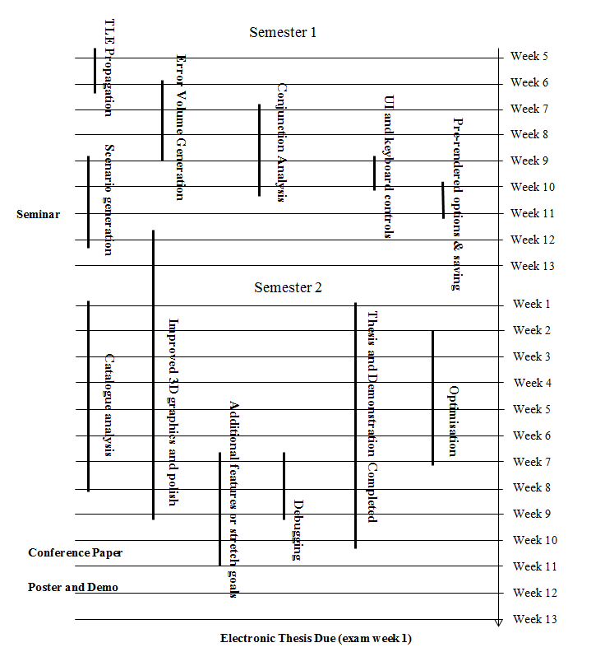The development schedule can be seen graphically in Fig 2.1.

Figure 2.1 the development schedule of the project over the two semester period

The largest amount of the work will be completing the software and the milestones have been written to reflect this. Work on sections of the thesis research will start early in semester two and be a continuous job until week 10. The milestone details for monitoring the completion of this research:

TLE Propagation

**Additional Resources Required:** None

**Duration:** Two weeks

**To be completed by:** Week 6, Semester 1

**Successful completion criteria:** A functioning propagation visualisation taking an input TLE file.

Error Volume Generation

**Additional Resources Required:** None

**Duration:** Three Weeks

**To be completed by**: Week 9, Semester 1

**Successful completion criteria:** Option to display uncertainty/error volumes graphically for individual orbital objects. Three weeks allocated to allow for graphical work.

Conjunction Analysis

**Additional Resources Required:** None

**Duration:** Three Weeks

**To be completed by**: Week 10, Semester 1

**Successful completion criteria:** Option to calculate the conjunction probability of two objects. Three weeks to allow for difficulty of task.

UI and Keyboard Controls

**Additional Resources Required:** None

**Duration:** One Week

**To be completed by**: Week 10, Semester 1

**Successful completion criteria:** Ability to interact and control camera and other interactive element implemented

Pre-Rendered Options & Savings

**Additional Resources Required:** None

**Duration:** One Week

**To be completed by**: Week 11, Semester 1

**Successful completion criteria:** Options to pre-render and save existing orbital data in system so as to not require re-computing.

Scenario Generation

**Additional Resources Required:** None

**Duration:** Three Weeks

**To be completed by**: Week 12, Semester 1, working demo for week 11 seminar

**Successful completion criteria:** Generate closed scenarios to test and demonstrate functionality of system.

Improved 3D Environment and Polish

**Additional Resources Required:** None

**Duration:** Twelve weeks

**To be completed by**: Week 9 Semester 2

**Successful completion criteria:** Improve 3D environment and polish interface. Milestone will be quite steadily worked on throughout semester 2.

Catalogue Analysis

**Additional Resources Required:** High power computing desirable*

**Duration:** Eight weeks

**To be completed by**: Week 8 Semester 2

**Successful completion criteria:** Functionality to perform collision analysis on entire space catalogue and be completed in parallel with efficiency and optimisation. Milestone given plenty of time to achieve. Expected tol be challenging

Optimisation

**Additional Resources Required:** None

**Duration:** Five weeks

**To be completed by**: Week 7 Semester 2

**Successful completion criteria:** Optimisation of program to improve run times. Time allocated to allow for testing and trials of different optimisation techniques.

Debugging

**Additional Resources Required:** None

**Duration:** Two weeks

**To be completed by**: Week 7 Semester 2

**Successful completion criteria:** Thoroughly debug program.

Main Sections of Report and Demonstration Completed

**Additional Resources Required:** None

**Duration:** Ten weeks

**To be completed by**: Week 10 Semester 2, drafts expected in week 7

**Successful completion criteria:** Conference Paper, demonstration, poster, and thesis completed

Additional features or stretch goals

**Additional Resources Required:** None

**Duration:** Four weeks

**To be completed by**: Week 11 Semester 2

**Successful completion criteria:** Add any additional innovative features or stretch goals for demonstration

References

[1] - Allianz Global Corporate & Speciality, “*Space Risks: A new generation of challenge”, (*2012)

[2] - U.S. Congress, Office of Technology Assessment, “*Orbiting Debris: A Space Environmental Problem-Background Paper”, (*September 1990), *OTA-BP-ISC-72,* Washington, DC: U.S. Government Printing Office

[3] - NASA Orbital Debris Program Office, “*Orbital debris – Graphics”, (*2009, July). , Accessed April 1, 2016, URL: http://orbitaldebris.jsc.nasa.gov/photogallery/beehives.html

[4] - Space Environment Research Centre, “*SERC Partners”,* (2014). Retrieved April 1, 2016, URL: http://www.serc.org.au/research/program-3/

[5] T.S. Kelso, “*Analysis of the Iridium 33-Cosmos 2251 Collision”*, Centre for Space Standards & Innovation, (2009)

[6] – V.T. Coppola, S. Dupont, K. Ring, F. Stoner, “*Accessing Satellite Conjunctions for the Entire Space Catalogue using COTS Multi-core Processor Hardware”,* (2014)

[7] – S. Alfano, “*Review of Conjunction Probability Methods for Short-term Encounters”*, (2013), American Institute of Aeronautics and Astronautics

[8] - R.W. Ghrist ,D. Plakalovic, “*Impact of Non-Gaussian Error Volumes on Conjunction Assessment Risk Analysis”, (2012),* a.i. Solutions, Inc., Colorado Springs, CO 80915

[9] - Y Jianjun, Z Jianqiu, Z Zesen, *“Gaussian Sum PHD Filtering Algorithm for Nonlinear Non-Gaussian Model”, (2008),* Department of Electronic Engineering, Fudan University, Shanghai 200433, China

[10] - G. Terejanu, P. Singlay, T. Singhz, P.D. Scottx, “*Uncertainty Propagation for Nonlinear Dynamical Systems using Gaussian Mixture Models*, (2008), American Institute of Aeronautics and Astronautics

[11] – T. Hobson, - “*Sensor Management for Enhanced Catalogue Maintenance of Resident Space Objects”,* (2014), The University of Queensland, Section 6.2

[12] – X. Xu, Y. Xiong, “*A Method for Calculating Collision Probability between Space Objects”*, (2013)

[13] – R. Hall, Dr. S. Alfano, A. Ocampo, “*Advances in Satellite Conjunction Analysis”*, (2010)

[14] - D.A. Vallado, *“Fundamentals of Astrodynamics”*, (2007) Third Edition, Microcosm Press, Hawthorne, CA, and Springer, New York, NY.

[15] D.A. Vallado, P Crawford, *“SGP4 Orbit Determination”*, (2008), Center for Space Standards and Innovation, Colorado Springs, Colorado, 80920

[16] CelestTrak, *“FAQ: Two-Line Element Set Format”,* Retrieved April 4th, 2016, URL: https://celestrak.com/columns/v04n03/

[17] AGI, “*AGI Software for SSA*”, (2014), White Paper

[18] Scitor Corporation*, “Space Track Data Catalogue”*, Retrieved April 5th, 2016, URL: https://www.space-track.org/